Contents
Configuration 1
How to configure and enable the User Defined Calendar 1
How to extend the User Defined Calendar 3
How to assign User Defined Calendar 4

Configuration

How to configure and enable the User Defined Calendar

Control Parameters
- Click System Params then Reference A - C, followed by Control Parameters
- Query Company 1
- Select General Parameters - 4
- Enable User Defined Calendar Entry
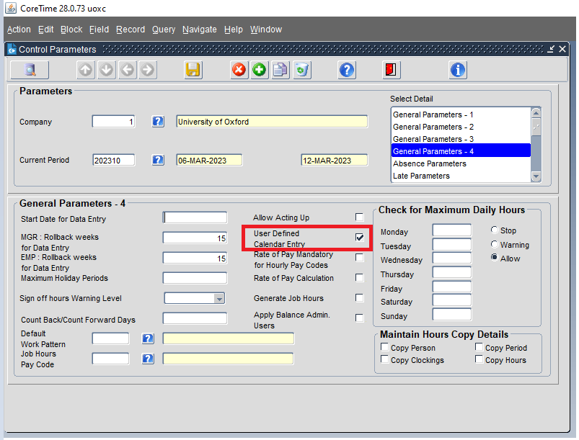

From the same screen, select Advanced Options. Click the green + button to add a new row and enter TIMESHEETS - RUN MONTHLY
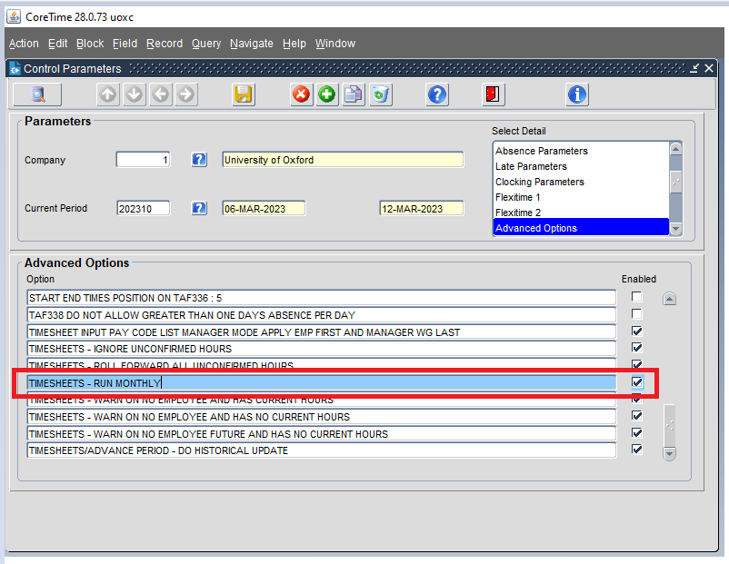
System Calendar
- Click System Params then Calendars, followed by System Calendar
- Query the Company
- Click User Defined Periods
- Add a Code and Name for the Calendar
- Set the Data Entry Offset to 0
- Click Save
You will next have to generate the periods, and lastly, the UDC needs to be assigned to Work Groups
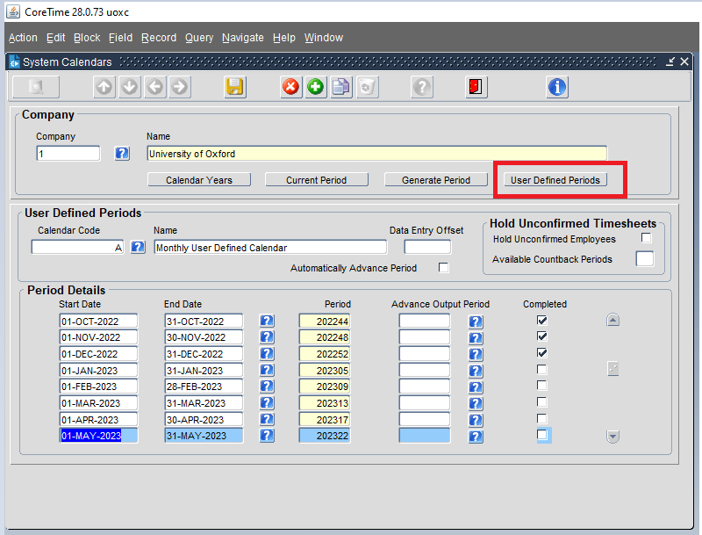

How to extend the User Defined Calendar

If you need to extend a user defined calendar, follow the steps below on Back-Office,
- Go to CoreTime
- Click on System Params
- Select Calendars then click System Calendar
- Query the relevant company
- Select User Defined Periods
- Select the Calendar Code
- Enter Start Date and End Date and press 'Tab' key to generate the period automatically
Note
- For a weekly calendar, there are 52 periods in a tax year. If your normal pay pay date falls on 5 April, then you have 53 periods,
- For a fortnightly calendar, there are 26 periods.
- For a monthly calendar, there are12 periods.
You need to ensure that your weekly and yearly calendars are extended to cover the periods in your UDC otherwise the period won't generate.

How to assign User Defined Calendar
To assign to a Work Group (all employees within that Work Group)
- Click CoreTime, System Params, Work Groups
- Query the Work Group.
- On General Parameters -1, go to the Pay Frequency option
- Use the Pay Frequency drop-down and select the UDC.
Note: The options here are based on the following: Weekly, Fortnightly and Monthly are all default system options are are NOT user defined calendar groups.
The options available after this will match the Description/Full name given to your User Defined Calendar (as opposed to the Calendar Code)
- Click Save.
- Select General Parameters - 2.
- Select the User Defined Calendar Group check box.
- Click Save.
To assign to a single employee (overriding Work Group)
- Click CoreTime, Pers. Data, Person Maintenance
- Query the employee.
- Select Work Group Override 2
- Use the Pay Frequency drop-down and select the UDC.
- Click Save.

